**Guinea country profile**

Published

6 November 2019

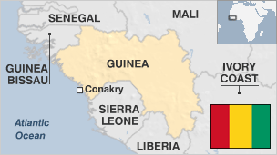

**Guinea's mineral wealth makes it potentially one of Africa's richest countries, but its people are among the poorest in West Africa.**

Experiments with socialism and a two-year rule by junta have taken their toll on prospects for development. The 2010 election ushered in civilian rule, but led to violent ethnic clashes as well.

In addition, hundreds of thousands of refugees from Liberia and Sierra Leone have strained Guinea's struggling economy.

The instability has generated suspicion and ethnic tension - as well as accusations between neighbours of attempts at destabilisation and border attacks.

* Read more [country profiles](http://news.bbc.co.uk/1/hi/country_profiles/) - Profiles by [BBC Monitoring](http://bbc.co.uk/monitoring)

**President: Alpha Conde**

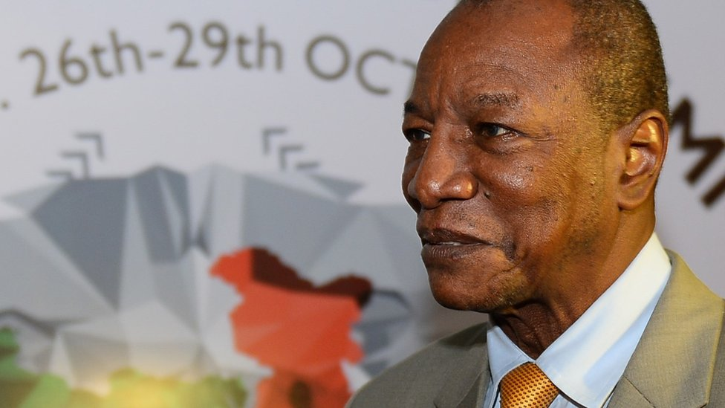image copyrightGetty Images

Alpha Conde became president in 2010 after a lifelong battle against a series of despotic and military regimes which sent him into exile and prison. It was Guinea's first democratic election since gaining independence from France in 1958.

However, the vote kindled ethnic tensions, as Mr Conde hails from the Malinke ethnic group, which makes up 35% of the population. The defeated, Cellou Dalein Diallo, is a member of the Peul ethnic group, to which 40% of Guineans belong.

Mr Diallo has repeatedly accused the president of sidelining his constituents, including many Peul.

Both allies and critics alike acknowledge his charisma and intelligence, but some also describe him as authoritarian and impulsive, someone who rarely listens to others and often acts alone.

His supporters however consider him untainted, a "new man" who has never had the opportunity to "participate in the looting of the country."

He was elected for a second term in 2015, but faced protests four years later when he tried to change the constitution and run for a third term.

# Guinea profile - Timeline

Published

14 May 2018

## A chronology of key events:

**1891** - France declaress Guinea to be a colony, separate from Senegal.

**1898** - Defeat of resistance to French occupation led by Samory Toure, great-grandfather of future President Ahmed Sekou Toure.

**1906** - Guinea becomes part of French West African Federation.

**1952** - Ahmed Sekou Toure becomes secretary-general of the Democratic Party of Guinea.

## Independence

**1958** October - Guinea becomes independent, with Ahmed Sekou Toure as president.

**1965** - Sekou Toure breaks off relations with France after accusing it of plotting to oust him.

**1984** March - Sekou Toure dies.

**1984** April - Lansana Conte and Diarra Traore seize power in bloodless coup. Conte becomes president while Traore is installed as prime minister.

**1985** - Attempted coup organized by Traore following his demotion to education minister.

**1990** - Constitution paving the way for civilian government is adopted.

## Democracy without peace

**1993** - First multiparty elections are held; Conte confirmed in office.

**1995** - Conte's Party of Unity and Progress wins 71 of the National Assembly's 114 seats.

**1996** - Some 30 people are killed and presidential palace set on fire as 25% of Guinea's armed forces mutiny over low pay, poor conditions.

**2000** September - Alpha Conde, leader of opposition Guinean People's Rally, sentenced to five years in prison for endangering state security and recruiting foreign mercenaries. He is pardoned in May 2001.

**2000** September - Start of incursions by rebels in Guinea's border regions with Liberia and Sierra Leone which eventually claim more than 1,000 lives and cause massive population displacement. The government accuses Liberia, the Sierra Leonean United Revolutionary Front (RUF) rebel group, Burkina Faso and former Guinean army mutineers of trying to destabilise Guinea.

**2001** February - Government deploys attack helicopters to the front-line in its fight with rebels.

## Referendum

**2001** November - Official results show constitutional referendum, boycotted by opposition, endorses President Conte's proposal to extend presidential term from five to seven years. Critics accuse Mr Conte of trying to stay in power for life.

**2002** March - Guinea, Sierra Leone, Liberia agree on measures to secure mutual borders and to tackle insurgency.

**2003** November - Opposition leader Jean-Marie Dore detained, subsequently released, after saying President Conte is too ill to contest December's presidential election.

**2003** December - President Conte wins a third term in elections boycotted by the opposition.

**2004** April - Prime Minister Lounseny Fall resigns while visiting the US.

**2005** January - President Conte survives what security officials say is an assassination attempt. Shots were fired as his motorcade passed through the capital.

**2005** July - Alpha Conde, head of the main opposition Guinean People's Rally, returns from exile in France. He is welcomed by thousands of supporters.

**2006** March - President Conte is flown to Switzerland for medical treatment. Opposition parties call for the formation of an interim government.

**2006** April - Prime Minister Cellou Dalein Diallo sacked.

## Strikes and protests

**2006** June - Crippling general strike suspended after eight days after trade unions, government agree on wages and prices of basic goods. Several student protesters were killed during unrest over the postponement of exams due to the strike.

**2006** October - President Conte fails to make his usual independence day speech, fuelling concerns about his health.

**2007** January - General strike called by unions, opposition in protest against the rule of President Conte. Several people are killed in clashes between demonstrators and police.

**2007** 13 February - President Conte declares a state of emergency, instructs the army to restore order following days of violent protests.

**2007** 26 February - President names Lansana Kouyate as prime minister under a deal to end the general strike.

**2007** May - Violent protests as soldiers demand better pay.

**2007** August - Government announces discovery of commercially viable reserves of uranium.

**2008** May - President sacks Lansana Kouyate as prime minister and replaces him with former minister of mines and ally Ahmed Tidiane Souare.

Soldiers begin a mutiny over pay.

## Conte dies, military seizes power

**2008** December - President Lansana Conte dies. Military seizes power. The coup meets with international condemnation, but many Guineans back the army's move.

Captain Moussa Dadis Camara emerges as leader of the new military junta and declares himself president.

Junta appoints former banker Kabine Komara as prime minister.

**2009** August - Military leader Captain Moussa Dadis Camara says presidential elections will be held on 31 January 2010 and elections for parliament in March. Despite a previous promise that he would not seek election, his supporters form a movement urging him to stand.

**2009** September - Soldiers open fire on a mass opposition rally at a stadium in Conakry, called to urge military ruler Moussa Camara to step down. The Guinean Human Rights Organisation says 157 are killed in the violence and over 1200 injured. The military government puts the death toll at 57, and bans all "subversive" gatherings.

**2009** October - The European Union, the African Union and the US United States impose sanctions.

The United Nations sets up a tribunal to probe the death of at least 150 protesters, who died when troops fired on an anti-government demonstration in September.

**2009** December - Captain Camara is shot in the head by a former aide.

**Junta leader shot**

**2010** January - After receiving treatment in Morocco, Captain Camara goes to Burkina Faso to recuperate. Capt Camara agrees to stay abroad and leave his deputy Gen Sekouba Konate in charge.

Pro-democracy opposition leader and civilian Jean-Marie Dore is appointed interim PM to head a power-sharing government and oversee a return to civilian rule.

**2010** February - International Criminal Court (ICC) says September stadium massacre was a crime against humanity.

**2010** May - Campaigning kicks off for 27 June presidential election. Military junta promises to respect result.

**2010** June - Presidential elections. First round produces no outright winner.

**2010** October - Clashes ahead of run-off presidential elections.

**Conde elected**

**2010** November - Alpha Conde declared winner of run-off presidential race. Emergency declared after clashes between security forces and supporters of defeated candidate Cellou Dalein Diallo.

**2011** February - President Alpha Conde says the military junta in power before he took over left Guinea bankrupt.

**2011** July - Gunmen attack and partly destroy the residence of President Alpha Conde, who escapes injury. Hours later, the security forces arrest former army chief Gen Nouhou Thiam.

**2011** September - Police arrest hundreds of opposition activists protesting against what they say are attempts by President Conde to rig parliamentary elections in December. These are later postponed.

**2011** December - President Conde promises a review of mining contracts.

**2012** April - President Conde delays 8 July parliamentary elections, originally scheduled for late 2011. Opposition welcomes the move.

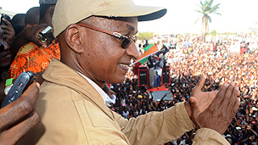image copyrightGetty Images

image captionOpposition leader Cellou Dalein Diallo meets supporters in the run-up to May 2013 polls

**2012** May - Security forces clash with protesters angered by the government's handling of forthcoming parliamentary polls.

**2012** November - Head of the treasury Aissatou Boiro - who fought against corruption - is shot dead.

**2012** December - Electoral commission sets date for parliamentary elections at 12 May 2013.

**2013** February - Armed forces chief General Kelefa Diallo - tasked with reforming the military - is killed in an air crash in Liberia.

**2013** March - One person killed in clashes between police and opposition supporters demanding transparency in elections planned for May.

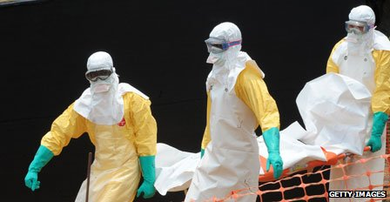image copyrightGetty Images

image captionAn Ebola virus epidemic spread from Guinea to neighbouring countries, killing hundreds within months

**2013** May - Parliamentary elections delayed again.

**2013** September - President Conde's Rally of the Guinean People comes out ahead in long overdue parliamentary elections. International observers note irregularities and opposition parties allege fraud, but the result is upheld by the Supreme Court.

**2014** February - Outbreak of the deadly Ebola virus in southern Guinea. It spreads to neighbouring Sierra Leone and Liberia, killing more than 600 by mid-July.

**2014** August - The World Health Organisation says the spread of Ebola in west Africa is an international public health emergency, and calls for a coordinated response.

**2014** September - President Obama announces that 3,000 US military personnel are being sent to west Africa to build new health facilities and to train health workers, as part of efforts to combat the Ebola epidemic.

The World Bank warns that the Ebola outbreak could have a catastrophic effect on the economies of Guinea, Liberia and Sierra Leone.

**2015** February - After brief respite in January, Guinea, along with Sierra Leone and Liberia, reports rise in new cases of Ebola.

**2015** April - Mass protests in Conakry over the timetable for presidential and local elections.

**2015** October - President Conde wins a second term.

**2017** April - Riots disrupt operations at bauxite mines in the north-west where residents complain about power cuts and high levels of pollution.

**2017** August - Thousands of opposition supporters march in Conakry to press the president to respect an agreement to organise local elections.

**2018** February - First local elections since military rule ended in 2005.

**2019** November - At least two people are killed in police crackdown on protests against bid by President Conde to change the constitution and let him run for a third term.